Default argument

Python allows to [define a function](https://www.tutorialspoint.com/python/python_functions.htm) with **default value** assigned to one or more formal arguments. Python uses the default value for such an argument if no value is passed to it. If any value is passed, the default value is overridden with the actual value passed.

Syntax:-

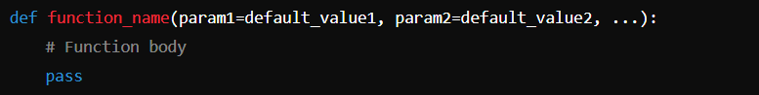

Example:-

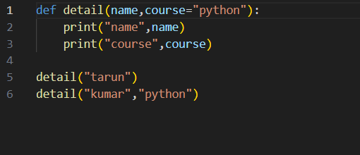

Output:-

